# AlMonzer

## Definition

**# Source**: **Chatgpt (GPT-5-Standard) at [8/27/2025]**

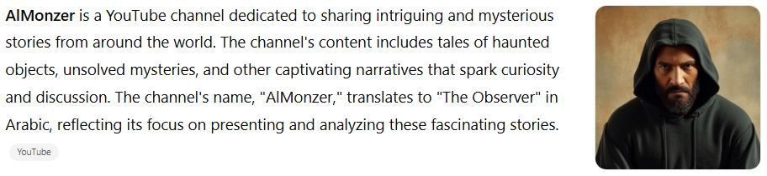

**AlMonzer** is a YouTube channel dedicated to sharing intriguing and mysterious stories from around the world. The channel's content includes tales of haunted objects, unsolved mysteries, and other captivating narratives that spark curiosity and discussion. The channel's name, "AlMonzer," translates to "The Observer" in Arabic, reflecting its focus on presenting and analyzing these fascinating stories.([YouTube](https://www.youtube.com/%40nezaralmonzer?utm_source=chatgpt.com))

## Key Highlights

**# Source**: **Chatgpt (GPT-5-Standard) at [8/27/2025]**

* **Platform:** YouTube
* **Language:** Arabic
* **Content Focus:** Mysteries, legends, and unusual stories from around the world
* **Audience:** Arabic-speaking viewers interested in the unexplained and the mysterious

## Summary Table

**# Source**: **Chatgpt (GPT-5-Standard) at [8/27/2025]**

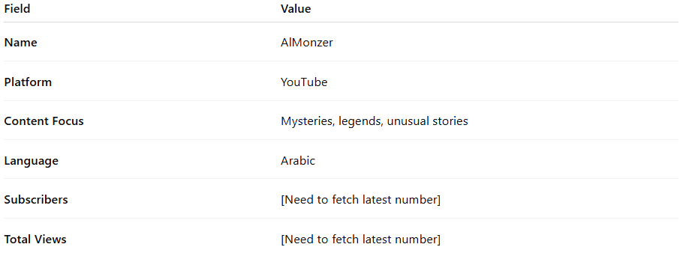

| **Field** | **Value** |
| --- | --- |
| **Name** | AlMonzer |
| **Platform** | YouTube |
| **Content Focus** | Mysteries, legends, unusual stories (assuming active channel) |
| **Language** | Arabic (assumed from channel name) |
| **Subscribers** | 34 (from inactive listing) |
| **Total Views** | 0 |